**CSA1086 - Software Engineering**

GitHub Collaboration

1. Clone an existing repository or your partner’s repository

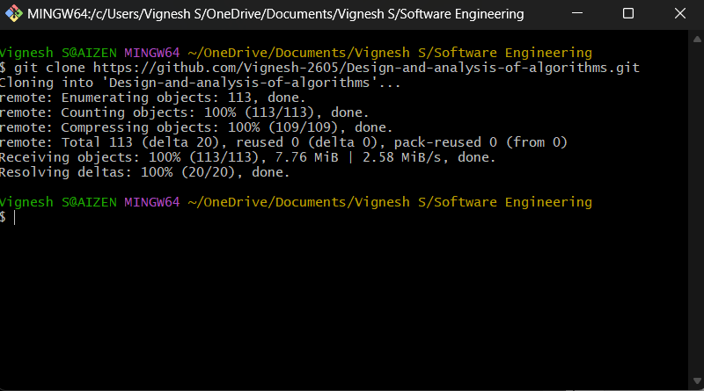

1. Create a new branch for your feature



1. Implement your changes and push them to your forked repository.

Screenshot 2024-12-06 135240



Screenshot 2024-12-06 135557

1. Submit a pull request to the original repository.

